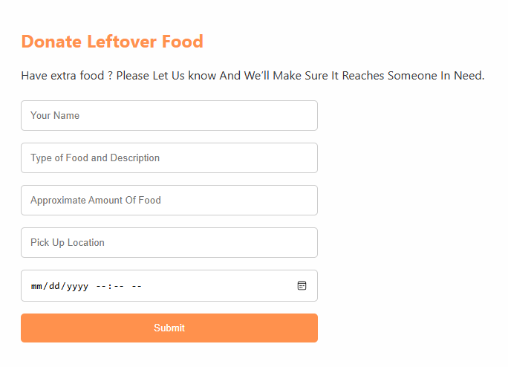

To donate food user has be fill all the data

Name-The person/organization

Food Description- Type of food

Food Amount- The Amount of the food to be picked up

Pick Up location- From where we can pick the food

Time- Current time

Post adding all the fields on click a “Code will be generated” [Gen Code]

To join as a volunteer to pick up and deliver the food to the needy user need to give all these data

Name- User name

Email-User Email

City/area- User’s city and area

Delivery Range- With in how much range user can deliver the food

Once the user register/log in based on user entered city/area and deliverable range respective [Gen Code] will be displayed.

Volunteer can check all the details [where to pick and when] by clicking on the Gen Code.

Once any volunteer clicked a Gen Code and selected the same code will not be displayed to any other volunteer.

Through Contact US both the users [ who is donating the Food and who is delivering the food] can contact to US if any query or suggestion by filling the data.